CHAPTER 5: Separating mixtures
Worksheet 5.1

Soluble or insoluble?
Science Quest 7: pages 182–184
Student: Class:
Substances that dissolve are said to be soluble. Those that do not are insoluble. This experiment investigates the solubility of some common substances in water.

You will need:
safety glasses and laboratory coat
heatproof mat
7 test tubes
test-tube rack
spatula
samples of:
salt sugar flour coffee sand
copper sulfate copper carbonate.
● Half-fill each of the test tubes with cold water.
● Label the test tubes: salt, sugar, flour, coffee, and so on.

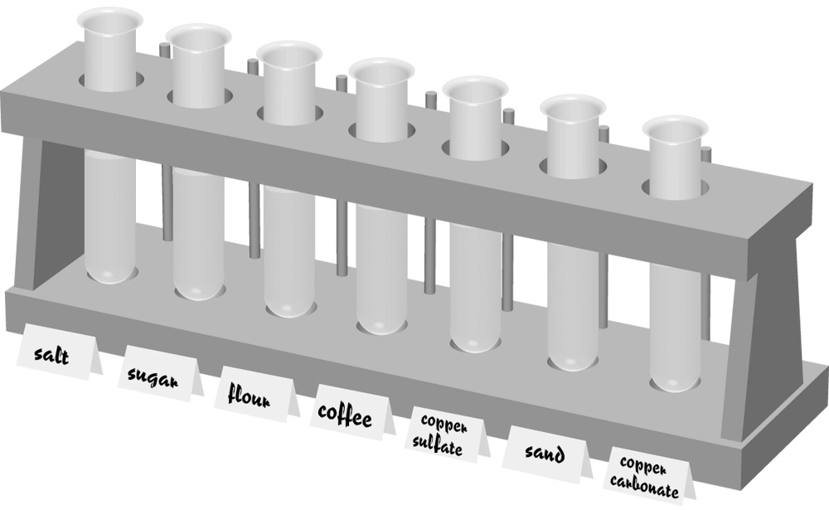

● Use a spatula to add a very small amount of each substance to its labelled test tube. Do not use more than a quarter of a spatula.
● Hold each test tube up to the light. Decide whether the mixture is clear or cloudy. Record your results in the table below.
● Decide whether each mixture is a solution or a suspension. Record this in the table.

Substance mixed with water | Clear or cloudy? | Solution? (yes/no)
Salt
Sugar
Flour
Coffee

1. Which of the substances dissolved in water?

2. How can you tell if a substance has dissolved?

3. Which of the mixtures could be separated by filtration?

4. Using one of your solutions from the experiments as an example, suggest a method that could be used to separate and collect the substance from the water.

